Random Spawn, Specific Up Time, Once a day Spawn.... -possible with xml?
I wanna put a moongate for a champ im going to make, but i want to make this champ special by giving access for it once a day (or three times a week). And I want it to be up for an hour. Anybody knows about a script like that? Or can anyone make one?

These are what i want in the script:

  - Totally Customizable Random Spawns:
    - Once a day,
    - Once in two days,
    - Twice In five days ......
  - Specific Up Time:
    - Disappearing 3 hours later after spawn,
    - Disappearing 1 hour later after spawn,
    - Disappearing 30 minutes later after spawn...
  - Spawned Object:
    - Can be a moongate (maybe it can be a custom moongate.cs you make - that way its easier to change what we want to spawn)
    - Can be a boss,
    - Can be any item...

I was kinda bored and i made this little demonstration movie - Enjoy!
_________________________________________________
Click Here To View It
_________________________________________________
Prince
My Barbecue - Crafted by Homer Simpson
PrinceArda, May 22, 2007 Report
#1 Like Reply

Malaperth New Member
XMLSpawner can do just about anything but scratch your ass if you follow the instructions.
Why is it that I'm never as smart as I thought I was yesterday?
My vast knowledge is only surpassed by my infinite ignorance.
<TheOutkastDev> i might have to hire an assassin to killl mal so that i can jump in front of the bullet and piss on him
Malaperth, May 22, 2007 Report
#2 Like Reply

PrinceArda New Member
that xml spawner is so.... general. It can do anything but the question is how.
Im new to xml spawner and i couldnt even make a npc emote! =(
All he does is stare at me!
I need a really detailed tutorial for xml spawner and i have to spend hours and hours in front of computer, tryin to figure out what that little triangle object does..
i will check xml fan forums, but not today. Its getting late here ~
Prince
My Barbecue - Crafted by Homer Simpson
PrinceArda, May 22, 2007 Report
#3 Like Reply

Malaperth New Member
Well, normally, Arte Gordon checks these forums as well as the script release forum, so if it has to do with XMLSpawner, he'll see it soon.
Why is it that I'm never as smart as I thought I was yesterday?
My vast knowledge is only surpassed by my infinite ignorance.
<TheOutkastDev> i might have to hire an assassin to killl mal so that i can jump in front of the bullet and piss on him
Malaperth, May 22, 2007 Report
#4 Like Reply

ArteGordon New Member
PrinceArda;685031 said:
I wanna put a moongate for a champ im going to make, but i want to make this champ special by giving access for it once a day (or three times a week). And I want it to be up for an hour. Anybody knows about a script like that? Or can anyone make one?

These are what i want in the script:

  - Totally Customizable Random Spawns:
    - Once a day,
    - Once in two days,
    - Twice In five days ......
  - Specific Up Time:
    - Disappearing 3 hours later after spawn,
    - Disappearing 1 hour later after spawn,
    - Disappearing 30 minutes later after spawn...
  - Spawned Object:
    - Can be a moongate (maybe it can be a custom moongate.cs you make - that way its easier to change what we want to spawn)
    - Can be a boss,
    - Can be any item...

I was kinda bored and i made this little demonstration movie - Enjoy!
_________________________________________________
Click Here To View It
_________________________________________________
Yes, you can certainly do all of those things.
To make a spawn that occurs every 3-5 days, just set the mindelay of the spawner to 3 days, and the maxdelay to 5 days.
To make the spawn last 1 hour, set the Duration property on the spawner to 1 hour.
XMLSpawnerFan -> How do I - Make limited duration spawns
You can also have it set to spawn between certain times of the day, or even times of the week or month.
XMLSpawnerFan -> Setting up Time of Day (TOD) limited spawns
As for your npc just staring at you, make sure that you are testing it as a player. Staff do not trigger npc dialogs or spawners by default.
Use the StaffCloak to quickly switch between player and staff accesslevels.
Another possibility is that you just have a long ResetTime for your npc dialog. The ResetTime is how long the npc will wait before timing out and resetting. You can set that via the [xmledit gump.
(edit)
note that you can easily spawn a moongate with a specified target location with a spawn entry like this
moongate/target/(5439,1150,0)/targetmap/felucca
The first line of the first rule in the forum rules and guidelines "Be respectful of others. "
For questions, information, and support for XmlSpawner and its addons, visit the
XmlSpawner Support Forum
ArteGordon, May 22, 2007 Report
#5 Like Reply

PrinceArda New Member
|e Gasp!
I Love XML spawner! =D
anyways... =)
Am i doing something wrong??
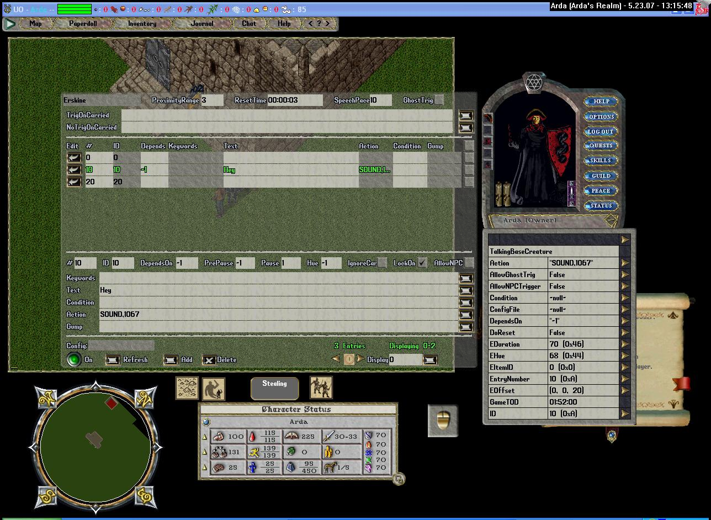
(edit)
I'm wearing the staff cloak, and i always will... ='(
Prince
My Barbecue - Crafted by Homer Simpson
PrinceArda, May 23, 2007 Report
#6 Like Reply

PrinceArda New Member
By the way,
how can i spawn the moongate (or any other item) with another item id?
ie i want to spawn a moongate-chair that way it will teleport when you sit on it, and it will ask if you want to go before teleporting.
and another thing, theres another way than just spawning, visibility. if i set up an item and put it somewhere, and if something can arange its visibility randomly, it would seem like spawning. << that is of course for the case if we cannot spawn in-game-custom items.
The thing i want to do is actually make a Throne with a custom hue, and make it spawn where a normal throne is. And it will look like the throne changed its color and got linked to somewhere. and this will happen rarely (or properly -like once every Thursday). When players sit on the throne, it will take them to a location with a big boss.........
And i will make a npc -which is a xmlquestnpc actually. and it will tell players to sit on the throne every Thursday between ### and ### hours. and it will make [sound 412 when it finishes talking.
I asked my question - generally - without giving much details about what i was going to do because i wanted to random-spawn other things too. but since im at this quest atm, i shall figure this one out first.
Thanks for your help. And
Have some + + + Karma
Prince
My Barbecue - Crafted by Homer Simpson
PrinceArda, May 23, 2007 Report
#7 Like Reply

ArteGordon New Member
What you tried should work, but I discovered that the SOUND keyword is slightly broken when used alone like that (works in spawner entries but not XmlDialogs). I'll fix it for the next release.
So to get the sound to work under these conditions, you need to lock it to something, such as the object the XmlDialog is attached to like
SETONTHIS/SOUND,1067
which will play the sound to all players around object the xmldialog is attached to.
For the moongate question, you can can change the itemid of any spawned item by just setting the ItemID property, like
moongate/itemid/11757/target/(5439,1150,0)/targetmap/felucca
which will make a moongate in the form of a throne.
The first line of the first rule in the forum rules and guidelines "Be respectful of others. "
For questions, information, and support for XmlSpawner and its addons, visit the
XmlSpawner Support Forum
ArteGordon, May 23, 2007 Report
#8 Like Reply

PrinceArda New Member
Sweet!! the sound worked perfectly!
now to build that moongate... Thank's a lot ArteGordon
Oh, and sorry i can't give you more karma... it says i have given you some already =)
Prince
My Barbecue - Crafted by Homer Simpson
PrinceArda, May 23, 2007 Report
#9 Like Reply

PrinceArda New Member
(if i spawn it now and wait for an hour) This should make a respawn seven days later between 00:00:01am and 23:00:00 right? and the duration will be 1 hour.
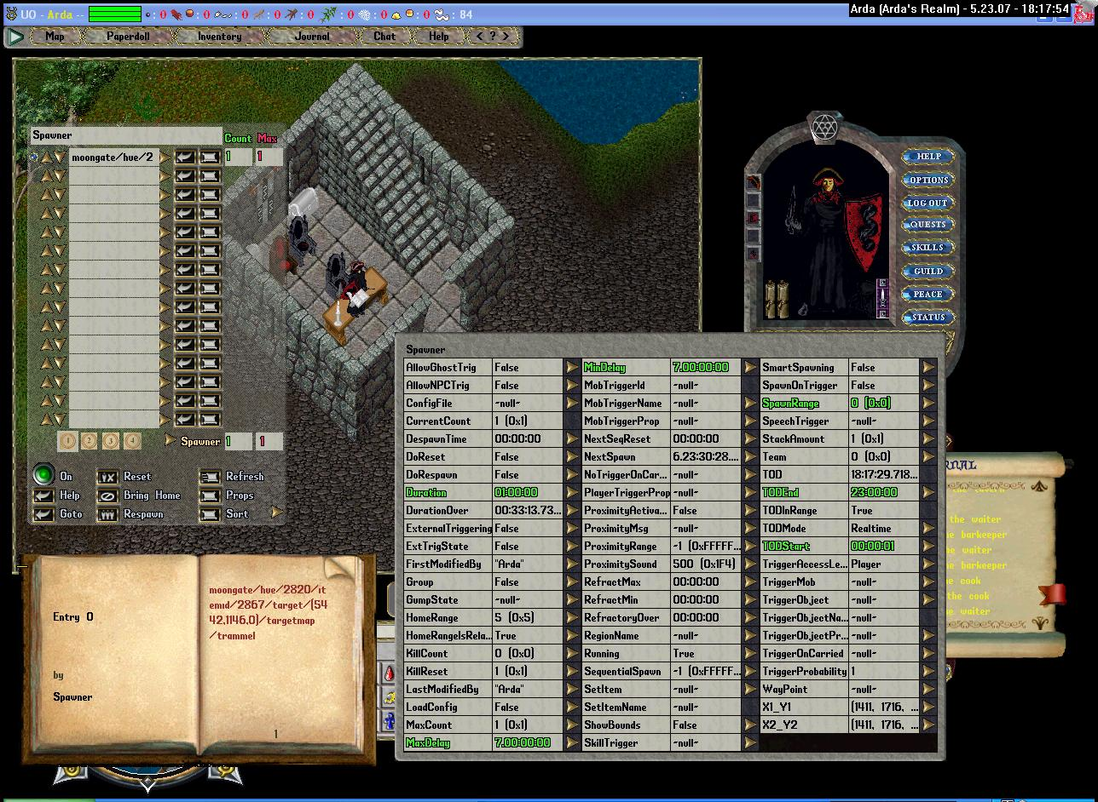
But that will change the spawn day and/or time with every respawn if i add the duration and stuff... and how is that tod going to work?
I want to make this spawn every Friday for example and i want to start the spawn that day, what should i enter for props like TOD, and Min/Max Spawn??
Prince
My Barbecue - Crafted by Homer Simpson
PrinceArda, May 23, 2007 Report
#10 Like Reply

PrinceArda New Member
I have edited the post ^
Now I'm asking something.
(i posted that 10th post by mistake and i changed it to a apologize... but some hours later i changed it back to a proper post.. and everyone thinks its the old post..)
Prince
My Barbecue - Crafted by Homer Simpson
PrinceArda, May 23, 2007 Report
#11 Like Reply

ArteGordon New Member
If you want this to spawn once a week on friday, you can just set the min/maxdelay to 7 days (just like you did), and then respawn it on a friday. After that it will spawn again every friday at the same time.
You dont need to set the TODStart and TODEnd in this case since the respawn time will just depend on when you actually reset/respawn it in the first place.
The first line of the first rule in the forum rules and guidelines "Be respectful of others. "
For questions, information, and support for XmlSpawner and its addons, visit the
XmlSpawner Support Forum
ArteGordon, May 23, 2007 Report
#12 Like Reply

PrinceArda New Member
But i want it to be unexpected.. even if its expected on friday.
cant we make a spawner to spawn the spawner that spawns the moongate?
:F Which means to spawn, the spawner < we set for a moongate.
that way a spawner could spawn the moongate-spawner everyday but between lets say 13:00 and 17:00, and the second spawner could make it spawn only on fridays for one hour..
its impossible isnt it? :/
if we cant make that happen, i will do it manually.. but it sucks because they will ask to spawn it from the staff members. =(
Note: :F is a smile which is holding itself not to laugh.
Prince
My Barbecue - Crafted by Homer Simpson
PrinceArda, May 23, 2007 Report
#13 Like Reply

ArteGordon New Member
if you want it to spawn every friday between say 13:00 and 17:00 regardless of when you respawn it, and have it last for an hour, what you would do would be
1) to make a spawn entry like
#CONDITION,GETONTHIS,RealDayOfWeek=#Friday ; moongate/itemid/11757/target/(5439,1150,0)/targetmap/felucca
that would make that spawn entry conditional on the results of the test 'GETONTHIS,RealDayOfWeek=#Friday '
The GETONTHIS keyword lets you access the RealDayOfWeek property on the spawner and then test the value against the enum value of 'Friday'.
If that condition is satisfied, then the entry can be spawned.
2) Set the Duration to 1 hour (like you did) to make the spawn last an hour.
3) If you want the spawn to exist between 13:00 and 17:00, you can set the TODStart and TODEnd to those times.
4) Then set the min/maxdelay on the spawner to 3-4 hours to make sure that it only spawned once in the 4 hour interval.
from xmlspawner2.txt
- added several timekeeping properties to XmlDialog entries that allows you to control their activation based upon time of the day, day of the week, day of the month, or phase of the moon. These properties are:
GameTOD - has values of the form hh:mm:ss, so 14:00:00 would be 2pm
RealTOD - has values of the form hh:mm:ss
RealDayOfWeek - has values Sunday, Monday, etc. Note, these are enums so when referring to them in property tests precede them with a #, like "RealDayOfWeek=#Monday"
RealDay - has values 1-31
RealMonth - has values 1-12
MoonPhase - has values NewMoon, WaxingCrescentMoon, FirstQuarter, WaxingGibbous, FullMoon, WaningGibbous, LastQuarter, WaningCrescent
There are a number of ways that you might use these new properties.
By setting the Home property on an npc which will cause it to wander to that location. By setting Home at different times, you can have your npcs go to different places throughout the day.
You could also have certain conversations that could only be carried out at certain times of the day, or days of the week.
For example, setting the Condition field in an xmldialog entry to
GameTOD>12:00:00 & GameTOD<16:00:00
would restrict its activation to between the times of 12 and 4pm
- added an example of the use of these new properties in a .npc file timeofday.npc, and a spawner example that loads it up onto an npc in timeofday.xml. To test it out, just do an "[xmlloadhere timeofday.xml". The npc will respond with the day of the week in his banter, and if you respond with the keyphrase "hello", you will get different responses depending on the time of day (game time), and even the day of the week (he doesnt work on Sunday).
and
- added the "#CONDITION,proptest" spawn control keyword that allows individual entries to be made conditional on the specified property test.
When combined with the new FastestPlayerSpeed and MovingPlayerCount properties, you can make spawn entries that will depend on the speed and number of nearby players with entries like
#CONDITION,movingplayercount<2 ; orc
which would only spawn the orc if fewer than 2 players were moving nearby.
#CONDITION,fastestplayerspeed>5 ; #PLAYER,3 ; orc
Which would only spawn the orcs if some player was moving faster than 5 tiles per second and would additionally have the orcs placed within 3 tiles of the triggering player when they are spawned.
You can use the same kind of condition tests that can be used anywhere else, such as compound tests or tests for properties on carried items, or triggering players, etc. For example,
#CONDITION,GETONTRIGMOB,skills.magery.value>100 ; lichlord
would only spawn the lichlord if the triggering player had magery greater than 100.
(edit)
note that even though the description of the timekeeping properties from xmlspawner2.txt refers to XmlDialogs, those properties are also available on xmlspawners.
Also note that in step 3, by using the TODStart and TODEnd feature, the spawn will only be allowed to 'exist' between those times. As soon as the TODEnd time is reached, all spawns on the spawner will be despawned even if they have only been around for a few minutes.
from xmlspawner2.txt
- added time of day properties that let you specify the period of the day during which spawns can occur. Time of day (TOD) is specified in 24 hour format. Note, if TOD start is later that TOD end, this indicates that the interval spans midnight. e.g TODStart=22:00:00 TODEnd=5:00:00 will enable spawns between 10pm and 5am every day. TOD windowing also applies to proximity-triggered spawns, so they can only be triggered during the enabled period. Spawns will be removed when outside of the TOD window.
If you just want to restrict the time window in which the item will be spawned, but always leave it around for 1 hour even if that goes outside of the time window, then dont use the TODStart and TODEnd feature. Instead you can add the time of day test to your spawning #CONDITION like
#CONDITION,GETONTHIS,RealDayOfWeek=#Friday & RealTOD>14:00:00 & RealTOD<17:00:00 ; moongate/itemid/11757/target/(5439,1150,0)/targetmap/felucca
The first line of the first rule in the forum rules and guidelines "Be respectful of others. "
For questions, information, and support for XmlSpawner and its addons, visit the
XmlSpawner Support Forum

