Written by: Godfood 12/26/05
XMLSpawner Basic's: Part 1, The Main Spawner Gump
Skill Level: Beginner
First thing first, Download XMLSpawner2 and install it.
Next step is to start up your RunUO Server and log in.
My suggestion is to head over to Green Acres while learning how to use this spawner system. It makes it easier for clean up.
- Type [set map Trammel, Then click on yourself once the target cursor comes up.
- Then Type [go 5400 1200 0 and hit enter.
Once you've reached the spot you wish to use, add a spawner, type [add xmlspawner and click where you want to place the spawner. You should now see this on the ground where you clicked.
Next, Double click on the spawner. (The thing in the picture above). This will bring up the main Spawner gump.
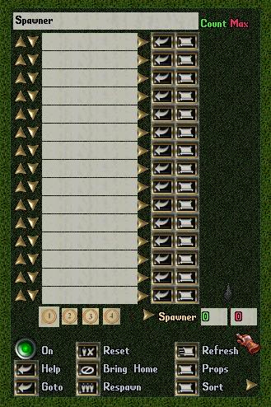
Now we want to name our spawner. In the first textbox where it says spawner, delete the text and type in Walkthrough. then click the buton to save the changes you made to the name.
Now that we have named our Spawner, let's move down just below where you typed in the name to the first entry box 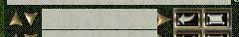
This is where you add the things you want to spawn. We're going to spawn a rat. So, click in the text box and type in rat.
If you are unsure of the correct spelling for something, you can hit the button to the right of the text box and it will open up a gump listing all of the possible valid spawn objects that contain the string "rat".
Next you want to hit the Up Arrow just to the left of the text box. This will increase the MAX field to 1. Meaning, The maximum number of this creature the spawner will have active at any given time is 1.
Your text box should now look like this 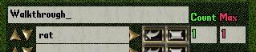, and you should see a rat running around near the spawner.
We also want to spawn 3 cat's. So move to the text box just below our rat, and type in the word cat and hit the Up Arrow to the left of the text box 3 times. It should now say 3 in the MAX column, 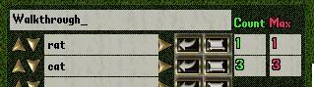and we should have 1 rat, and 3 cats runing around near the spawner now.
Repeat the process for any additional creatures you want to spawn on this spawner.
Now we're going to move down just below the last text box to this . the numer's on the right represent the TOTAL number or creatures currently spawned, and the MAXIMUM numer of creatures the spawner will allow at any given time.
The number's on the left are the 4 page's of spawn entry's. That's right, there's 4 pages worth of entry boxes. That means you can have a total of 60 different creatures on one spawner. Just click on the number of the page you want to go to.
Now we're on to the last section of the gump. The controls.
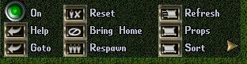
First thing is the round button in the top left, This button will turn the spawner ON and OFF. When turned ON the spawner will spawn creatures when needed, when turned OFF the spawner will not spawn creatures. Just to the right of the on button, is the RESET button. The reset button will do 2 things, First it will turn the spawner OFF, Secondly it removes any creatures it currently has spawned. A little more to the right and we find the REFRESH button which we used earlier. Anytime you change something in the textboxes, hitting this button will tell the spawner that there have been changes made.
Now, back to the left and below the on button, is the HELP button. I will cover this button and what it all means in another tutorial later. To the right of the help button is the Bring Home button. Clicking this button will bring any creatures the spawner is controlling to the same place the spawner is located. All the way to the right is the PROPS button. Again, I will cover this button in another tutorial.
In the bottom left hand corner is the GOTO button. Clicking this button will take you to the same spot as the spawner. In the middle on the bottom is the RESPAWN button. Click the respawn button will remove all creatues currently being controlled by the spawner, and start the spawning process over. The final button is the SORT button, This button to shall be covered in another tutorial.
I Have included the saved .XML Spawner file Just in case anyone want's it.
Once You've downloaded the file, Place it in your RunUO/Spawns folder. Then Type [xmlloadhere walkthrough1.xml in game to place the spawner.
You should now be able to do basic spawning with the XMLSpawner2 by: ArteGordon
Attached File ( Number of downloads: 365 )

