XmlQuest 4 Dummies
How to build a perfect quest
Ver. 0.3
1 Summary 2
2 Create a simple NPC 2
2.1 Build a dialog 2
2.2 Save a Dialog in a file 8
3 Spawn Creature 8
3.1.1 Autoreward not set or false 10

Summary
The simple way to start a quest is to meet a npc and start a dialog. I try to explain this simple situation in the XmlSpawner system. Before i build a very simple quest to undestand all mechanins of the system and then add a more complex situations.

Create a simple NPC
The simple way to build a human npc is to UO console :
[add xmlquestnpc

Ok on your video there is a human creature in this case her name is Anita.

Build a dialog

[xmledit

Click to “Add” Button and you have this page.

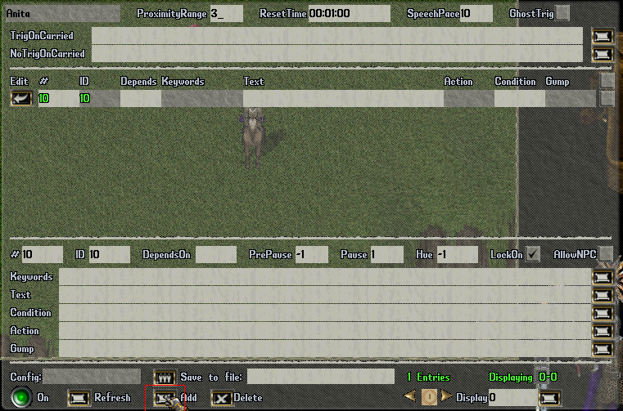

In this way you have added a blank entry in a dialog to Anita npc.

Now examine the GUMP in the fugure.

In the high part of figure there are global parameter of dialog.
Anita : NPC name
Proximityrange : tile from start the dialog
Resettime : minute when the dialog is reset

Ghosttrig : When AllowGhostTrig is true, then only ghosts and not players will trigger the spawner. When it is false, then only players and not ghosts will trigger.

TriggerOnCarried and NoTriggerOnCarried strings to allow checking for triggered PG items equipped or in backpack .

The other part of figure is to add entry to the dialog. Now i stat to build a dialog with pg.

I want Anita talks to all PG says “Good Morning” or “Hi”.

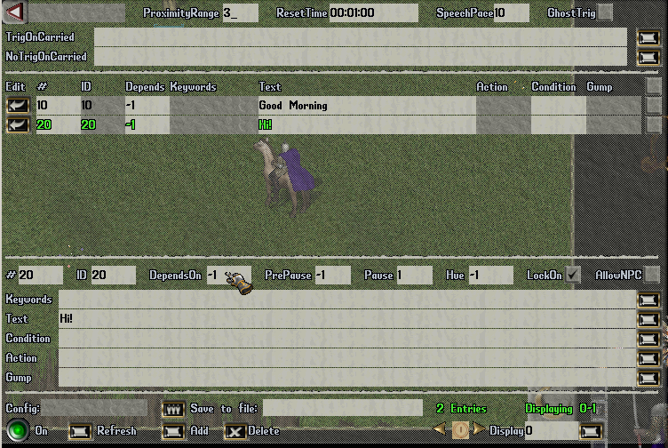

Speech entries when Trigger/NoTriggerOnCarried restrictions are specified. Currently, specifying DependsOn of -1 (banter) allows that entry to be activated regardless of triggering restrictions (nearby movement is sufficient). By specifying DependsOn of -2, that entry will behave like banter that will also be suppressed just like speech activated entries if triggering restrictions are not met.

On this specification I add only “Good Moorning” in Text box and -1 in to DependsOn and click add then insert “Hi!” in Text box and -1 in to DependsOn.

Ok, i try the dialog. Mmm doesn’t work. All Npc react by default to player access level only.
Command [props on Anita e change the TriggerAccessLevel to Administrator.

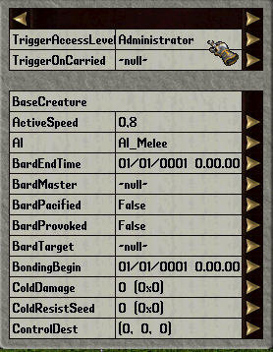

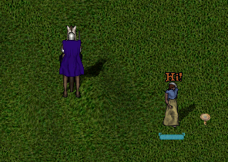

Ok. It’s works.
Now, I want now Anita says “Have got a little time form me?” after the “Hi” or “Good Morning”
I add “Have got a little time for me?” in Text box and 10,20 in to DependsOn and then add another entry that see a gump.
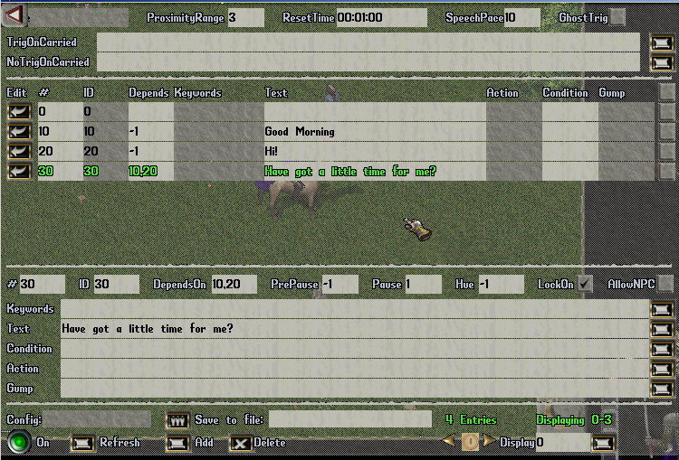

Now I add 4 entry of dialog in this way.

EntryNumber =40
Keywords = yes,ok
DependsOn =30
Gump = GUMP,Anita,4/Are you interested to earn some money for easy work?;Yes, off course;ok;How much?;money

EntryNumber = 50
Keywords = ok
DependsOn =40,60
Gump = GUMP,Anita,3/You must kill a ork "BOBO" not so far from here.

EntryNumber = 60
Keywords = money
DependsOn = 40
Gump = GUMP,Anita,4/200 gold for you. Do you like them?;Ok;ok;No, thanks;no

EntryNumber = 70
Keywords = accept
Action = GIVE/&lt;questholder/name/Kill Bobo/notestring/Bobo must go. Find him and kill him/objective1/KILLNAMED,Bobo,1/autoreward/true/rewardstring/@bag/ADD/gold,200
DependsOn = 50
GIVE/&lt;questholder = give to the PG a object “questholder”
name/Kill Bobo = name of the quest
notestring/Bobo must go. Find him and kill him = title of the quest
objective1/KILLNAMED,Bobo,1 = objective the quest
autoreward/true/rewardstring/@bag/ADD/gold,200 = when the quest is completed the PG receive in automatic the reward.

The questholder option will explain later in details in advanced quest.

The result in xmledit gump is over there:

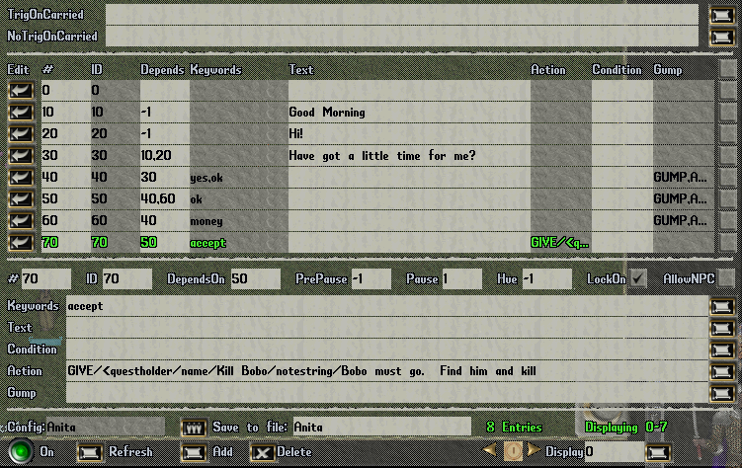

For no trigger the dialog when the PG have just the quest named Kill bobo I add the following code to NoTrigOnCarrier : Kill Bobo

Now I test the dialog. Follow the example of the gump in the dialog.
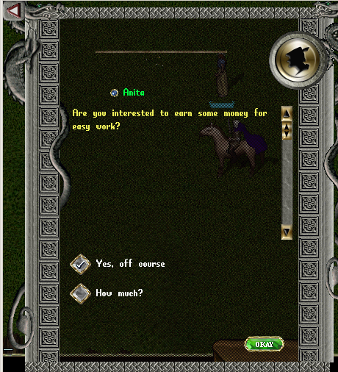

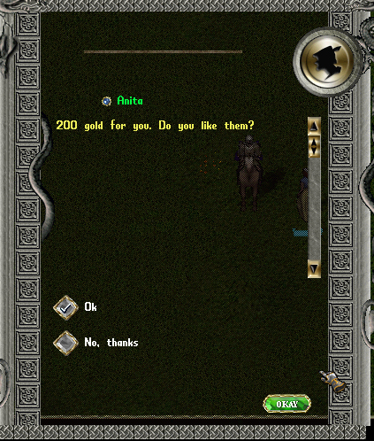

Ok it seem works. In the last gump you can accept the quest and in your bag there is a book.
This book is the explenation of the quest.
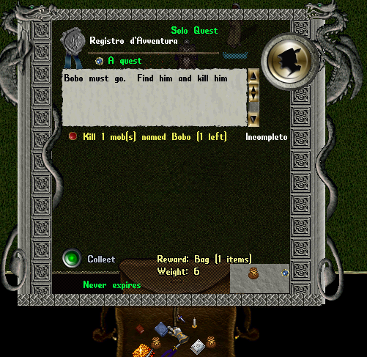

Save a Dialog in a file
Now, when the dialog work I want save the dialog in a specific file.

[xmledit

And click on anita.
In the bottom of gump there is a panel to insert a name of the file.

The file is saved in RunUO Core directory / XmlQuestNPC/Anita.npc

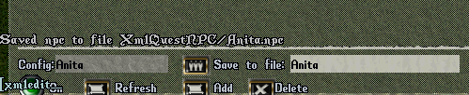

The first step is done.

But your question is and the orc?where is he spawned?when?ecc.

Spawn Creature

For add a xmlspawner from UO console is:
[add xmlspawner

Click on a object created and a gump appear.
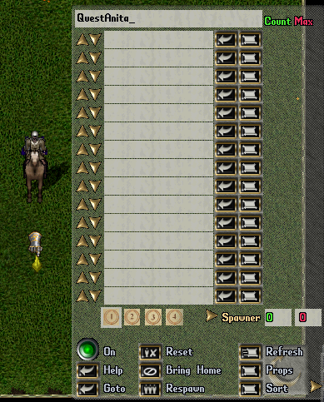

This a list of the creature for this point.
In this point spawn npc Anita in this way add to the first row the follow text:
xmlquestnpc,1/name/Anita/talktext/yes/configfile/Anita/loadconfig/true/TriggerAccessLevel/4
Explaine the code:
xmlquestnpc,1 = create a female npc
/name/Anita = name is Anita
/talktext/yes/ = this option when you click on Anita add a Talk option to start the dialog.
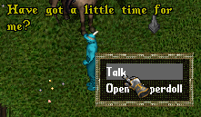
configfile/Anita/loadconfig/true/ = read the configuration from file Anita.npc
TriggerAccessLevel/4 = All PC trigger the spawn

Now, i want spawn the orc Bobo.

Go not so far from other xmlspawner and add another.
Add to the first row this code:
orc/name/Bobo
Now this is the situation:
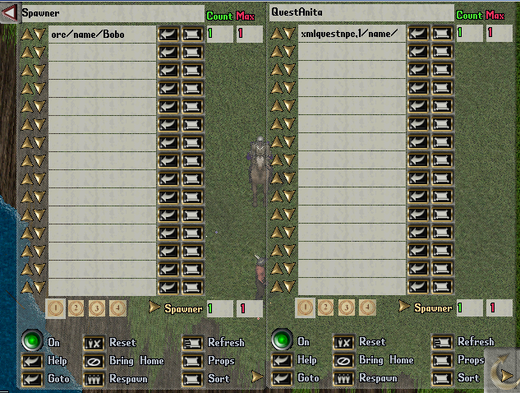

Now I save the spawner (save all xmlspawner in play) with
[xmlsave anitaquest.xml

For load the spawner:
[xmlload anitaquest.xml

Advanced Questing

Autoreward

In the quest the reward is given to the player in auto-mode when the quest finished. Now I want that the player return to Anita for his reward.

[xmledit
On Anita and modify #70 entry in this way :

GIVE/<questholder/name/Kill Bobo/notestring/Bobo must go. Find him and kill him/objective1/KILLNAMED,Bobo,1/autoreward/false/rewardstring/@bag/ADD/gold,200

Ok, now when the player kill bobo and the first objective is completed, the player must return to anita for the reward.

Multiple dialog to the same NPC

I want in the dialog two different starting points for the different conversational branches: one for starting dialog and other fro ending dialog(reward).

I must modify the actual dialog.
Delete all triggered condition.

[xmledit on Anita NPC.
Edit #10 and #20 entry
Add a condition:
~GETONCARRIED,Kill Bobo,visible=true

This string mean not player carried a object named “Kill Bobo”

I add a single entry 80
Condition :
GETONCARRIED,Kill Bobo,completed1=true

Gump =GUMP,Anita,0/I see Bobo corpse not so far from here. Compliments! Here your reward
Action:

DependsOn =-1
I add entry num.90 with

DependsOn = 80
Keywords = done
Action =
GIVE/{GETONCARRIED,Kill Bobo,rewardstring}; TAKE/Kill Bobo
GIVE/{GETONCARRIED,Kill Bobo,rewardstring}; = give the reward to player in the backback

Action = TAKE/Kill Bobo

TAKE/Kill Bobo; = delete on the backback the questholder (quest book)

ATTENTION: if you want manage other branches dialog you must pay attention bencause only one brach is execute. Ex: simple example your quest is with two objective and you decide to manage the return of player when he have completed the first objective form more information.
The branch is similar of the follow:
entry 1
ID 1
DependsOn -1

Condition GETONCARRIED,QuestName,completed1=true & GETONCARRIED,QuestName,completed2=false
(this would start your branch involving completing objective 1 but not 2)

Quote:
entry 2
ID 2
DependsOn -1
Condition ~GETONCARRIED,QuestName,visible=true
(this would start your branch for when the player did not yet have the quest)

entry 3
ID 3
DependsOn -1
Condition GETONCARRIED,QuestName,completed2=true
(this would start your branch involving completing objective 2)

PlayerMade (Staff) Quest
For Staff quest the GM have the possibility to create the quest (questholder) from gump.

[add xmlquestmaker

Click twice on xmlquestmaker and a quest book is added on your bag.

